Khaman Dhokla – Soft Steamed Chickpea Flour Bread
A classic savoury chickpea flour cake from the garden state of Gujarat in Western India
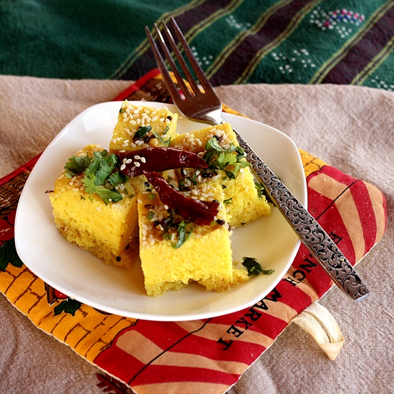
I have found that using a simple round cake tin works best for me.

The tempering needs to be done with care, essentially allowing the flavours to settle. I have found allowing about half an hour to let the flavours rest goes a long way to soft and tasty Dhoklas.

You could enjoy this with a side of green chutney, or with a side of tamarind chutney.

Prep Time: 60 minutes
Cook Time: 45 minutes
Eating Time: 5 minutes

Ingredients

For the batter
- 1 cup of gram flour (besan)
- 1 cup of yogurt
- 3/4 teaspoon turmeric
- 1/2 cup of water
- 3 tablespoons oil
- 1/2 teaspoon salt
- 1/4 inch piece ginger
- 2 green chilies
- 1 teaspoon sugar
- 1 lime
- 11/2 teaspoons eno fruit salt or 1/2 alka seltzer tablet, crushed

For the tempering
- 1 tablespoon oil
- 1 teaspoon black mustard seeds
- 10 curry leaves
- 4 dried red chilies
- 1/2 teaspoon asafetida
- 1 teaspoon sugar
- 1 lime
- 4 tablespoons water
- 1/2 teaspoon salt
- Sesame seeds to garnish
- 1 tablespoon chopped cilantro

Method:

- Place the gram flour in a mixing bowl and whisk to remove any lumps and add in the yogurt and the turmeric and beat well.

- Stir in the water and the oil and salt and mix until smooth.

- Place the ginger, green chilies, sugar in a mixer and cut the lime and squeeze in the lime juice and blend until the mixture is a smooth paste.

- Stir this into the gram flour mixture and let it rest for 15 minutes.

- While this is resting, grease a 9-inch round cake pan.

- Heat water in a large wok until the water begins to simmer. Invert a trivet onto the simmering water.

- Stir in the eno or crushed half-alka selzer tablet into the batter, it should start bubbling immediately.

- Quickly pour the mixture onto the cake plan and place over the trivet in the simmering pan. Cover the wok and let the mixture steam for about 35-40 minutes on medium-low heat. The cake should be fairly firm and a knife inserted in the centre should come out clean when done.

- Turn off the heat and let the cake rest for 15 minutes, invert the cake onto a plate.

- Heat the oil for the tempering, working quickly add in the mustard seeds and wait until they crackle, add in the curry leaves, dried red chilies, asafetida and the sugar and turn off the heat.

- Cut the lime and squeeze in the juice and add in the water and turn on the heat and bring to a simmer.

- Turn off the heat, allow it to stand for a half hour, then re-heat, and pour this mixture over the dhokla and let it rest until the liquid is absorbed.

- Sprinkle with the sesame seeds and cilantro. Cut into squares and serve.

